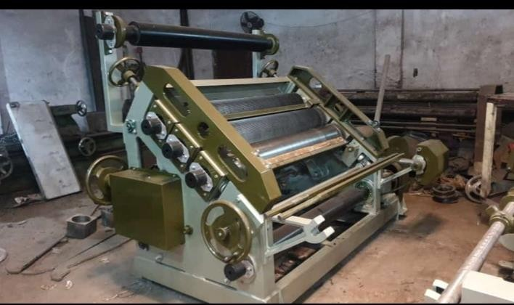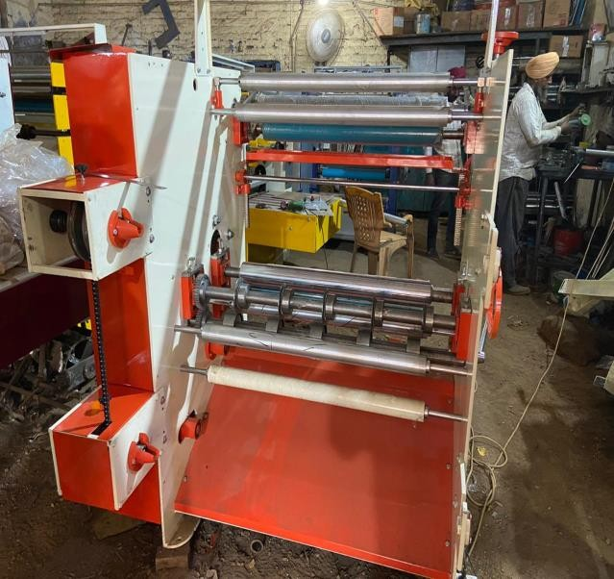

- One Reel to Sheet Cutter (Size Changeable with Gear Complete with Electricals & A.C Drive Size 32”.
Technical Specification:

  - Power Require 3 HP/1HP Three Phase or Single phase 412 Volt AC.
  - Speed Minimum (Ft/Min) 300.
  - Minimum Distance 2 Dies 3”.

One Sheet Pasting Machine with Hard Chrome Rolls Complete
- Standard Accessories Size 85”.

Technical Specification:

Motor Require 0.5 HP Three Phase 415 Volt AC.
  - Speed Minimum (RPM) 150

One Oblique type Corrugation machine Size 52”
  - Machine main motor 7.5HP

1 set flute roller any
  - Flute Roller Material EN9

Machine Bearing Mounted
  - 3 PC Heater 11 KW each

Machine Drive with variable speed drive control panel
  - One pre heater 3 kwt

All Motors Control Panel ISO make
  - One Hydraulic Reel Stand of 2 HP Amritsar make & completewith accessories

One Four Bar Rotary Cutting Machine with Electricals with High Carbon Eastern Brand Knifes with 2 HP Siemens Motor Size 85”.

Technical Specification:

Power Require 3 HP Three Phase 412 Volt AC.
  - Speed Minimum (Ft/Min) 300.

Minimum Distance 2 Dies 3”.

With Great Pleasure We Introduce Ourselves As Leading Manufacturers Of Paper Cup Machines And Moulds. As Per Telephonic Conversion We Are Forwarding Quotation For Your Kind Consideration.

S.No. | Product | Amount | Quantity | Total
1. | One Sheet Pasting Machine with Hard Chrome Rolls Complete | 1,60,000.00 | 01 | 1,60,000.00
2. | One Oblique type Corrugation machine Size 52” | 7,50,000.00 | 01 | 7,50,000.00
3. | One Reel to Sheet Cutter (Size Changeable with  Gear | 3,20,000.00 | 01 | 3,20,000.00
4. | Silver paper lamination machine | 3,20,000.00 | 01 | 3,20,000.00
5. | One two Bar Rotary Cutting Machine with Electricals with High | 2,50,000.00 | 01 | 2,50,000.00
 | Total Amount |  |  | 18,00,000.00
 | GST/IGST ( 18% ) |  |  | 3,24,000.00
 | TOTAL |  |  | 21,24,000.00

Terms and Condition

Our authorized Banking Partner(s)
1 ICICI BANK- GROW INDIA, ACCOUNT NO-046505500306, IFSC CODE- ICIC0000465, BRANCH, P P ROAD BUXAR, BIHAR.
2. AXIS BANK – GROW INDIA, ACCOUNT NO- 919020096530477, IFSC CODE- UTIB0001816,
BRANCH, P P ROAD BUXAR, BIHAR.

Important Terms and Conditions:

- 60 % Advance at the time of order, Balance before dispatch of product.
- Loading/Unloading, Transportation and Packaging charges will be extra (GI won’t be responsible for any kind Of transport / loading and unloading damage).
- Insurance cost (if any) to be bear by customer/buyer.
- Amount once paid is not refundable.
- Goods once sold will not be taken back in any condition.
- Invoice issued by GROW INDIA will be only valid for any kind of future - - ---- -
claim/dispute/service/installation/delivery etc.

Other detailed terms and conditions
You are requested to kindly go through all the terms and conditions and clear your doubt if any to make our relationship stronger.

* Terms and Condition:-

1. Payment Terms: 60 % Advance at the time of order and balance payment before dispatch of machine.
- Price Ex Buxar: All prices are ex-factory Buxar. Commissioning and Installation Charges will be extra.
- Quotations: All written quotations automatically expire unless accepted within 15 days from the date quoted. All stenographic and clerical errors are subject to correction.
- Packing & Transportation: Packing and transportation charges will be charged extra, Company will not be responsible in case if any damage would be happening in transportation (GI won’t be responsible for any kind of transport/loading and unloading damage).
- Taxes Extra: all taxes/duties will be charged extra.
- Loading and unloading: Loading and unloading charges will be charged extra.
- Warranty: One year on Spare part of the machine from the date of supply. Company will be liable only in case of any manufacturing defects only and not will be liable if it burns or happens with short circuit. Only repair service free if need parts than charge should be extra.
- Insurance: Insurance to be arranged by you at your own cost.

- Road Permit: Please send road permit (i.e., e-way bill) for out station, if required.
- Note: Without any information company will not responsible for deposit payment in any other account.
- Delivery time: 04 – 08 weeks
12…Installation Service is NOT AVAILABLE for dealer/trader,here dealer or trader define who purchase the machine/product at dealer rate.Any guarantee and warranty also NOT AVAILABLE for dealer/trader.

- Paid amount is NON-REFUNDABLE [Refund is only possible if product is not dispatched within 6-8 weeks (in case of Indian machine) & within 10-12 weeks (in case of imported machine) after full payment received].
- Goods once sold will not be taken back in any condition.
- Grow India reserves the right to add or change the above terms and conditions and prices as and when required without giving any prior notice or assigning any reasons thereof.
- Once your order will be placed then it will not be cancelled under any circumstances.
- Disputes are under Buxar jurisdiction only.
- You are requested to kindly speak the company authorized personnel only
- If machine/product will get installed by any un-authorized personnel, Grow India won’t be responsible for any damages (and all warranty and guarantee stand cancelled).
- We do not have any bank account other than mentioned in QUOTATION.
- Any product which you want to buy apart from mentioned in this QUOTATION will be treated as a separate deal.
- We strongly suggest that do not deal with any un-authorized person even if he is saying that he is from Grow India.

Thanking you and assuring you best co- operation.

THANKING YOU GROW INDIA

